Low Level Design

Advance Image Downloader/Extractor

1. Introduction

The LLD for the design of downloading thousands of images from the internet for given orders (e.g. Cat, Dog) will give a comprehensive understanding of how the system will be designed and enforced to meet the conditions specified in the HLD.

1. Architecture

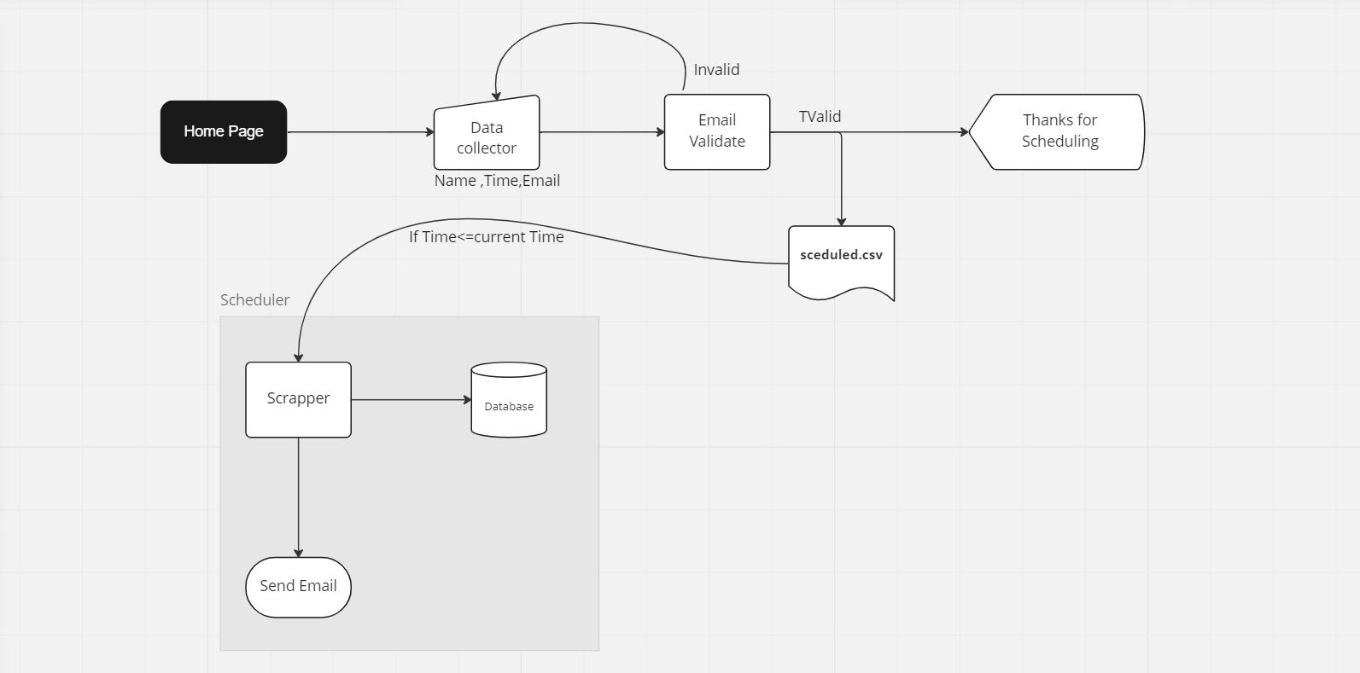

3. Architecture Description

The low- level design (LLD) for the project to download thousands of images from the internet for given conditions (e.g., Cat, Dog) is as follows:

* Web Scraping: The web scraping module will be responsible for downloading the images. It'll use the requests and Selenium library to scrape the images from websites.
* Image Store: The images will be stored in an original brochure with the applicable picking convention to fluently identify the images. (Initially we store the data to the local machine but we can also store the data to cloud to make it more open)
* Email Notification: The email notification module will notify the user once the images have been successfully downloaded. The email will contain a link to download the images.
* Logging: The logging module will log all the events that do during the download process, similar as starting the download, finishing the download, and any errors that may occur.
* User Interface: The user interface module will allow the user to enter the requirements (e.g., Cat, Dog) and the email address for notification and time for scheduling to download the images. The user interface module will also give a way for the user to check the status of the download.
* Scheduling: The scheduling module will allow the user to schedule the download process at a specific time. This will make it easier for the user to download images at a time when they're available.
* Validation: The validation module will validate the email address entered by the user to insure that it's a valid email address.

The above design will give a comprehensive solution to download thousands of images from the internet for given requirements, with the capability to schedule the download process, receive email notifications, and log all the events.